Cognitive Perspectives and Intelligence Theories

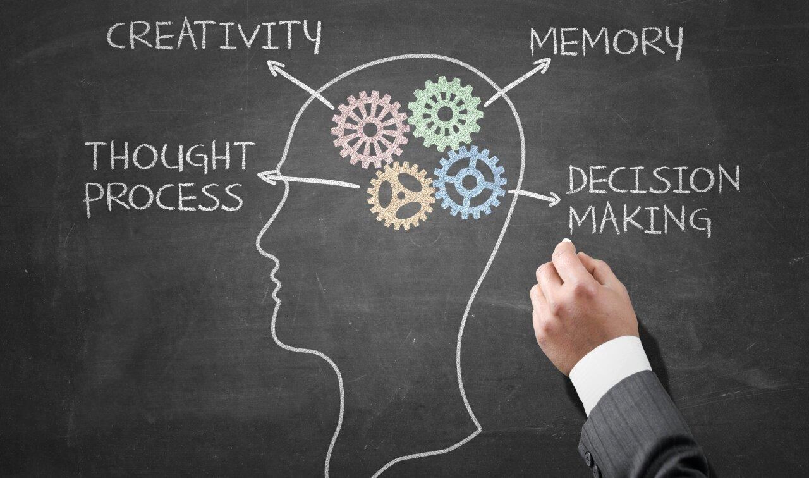
Cognitive Perspective
The Cognitive Perspective is a theory of learning that focuses on the mental processes involved in acquiring knowledge. Unlike behaviorism, which emphasizes observable behavior, the cognitive perspective explains that learning occurs through internal mental activities such as thinking, remembering, reasoning, problem-solving, decision-making, understanding, and perception. Cognitive psychologists believe that the human mind works similarly to a computer. It receives information from the environment, processes it, stores it in memory, and retrieves it whenever needed. Because of this, learning is not simply a change in behavior but also a change in the way people think, understand, and organize information.
For example, when a student reads a lesson, the brain does not simply memorize the words. Instead, it interprets their meaning, connects them with previous knowledge, and stores them in memory for future use. This explains why understanding a lesson is more effective than memorizing it without comprehension.

Gestalt Theory
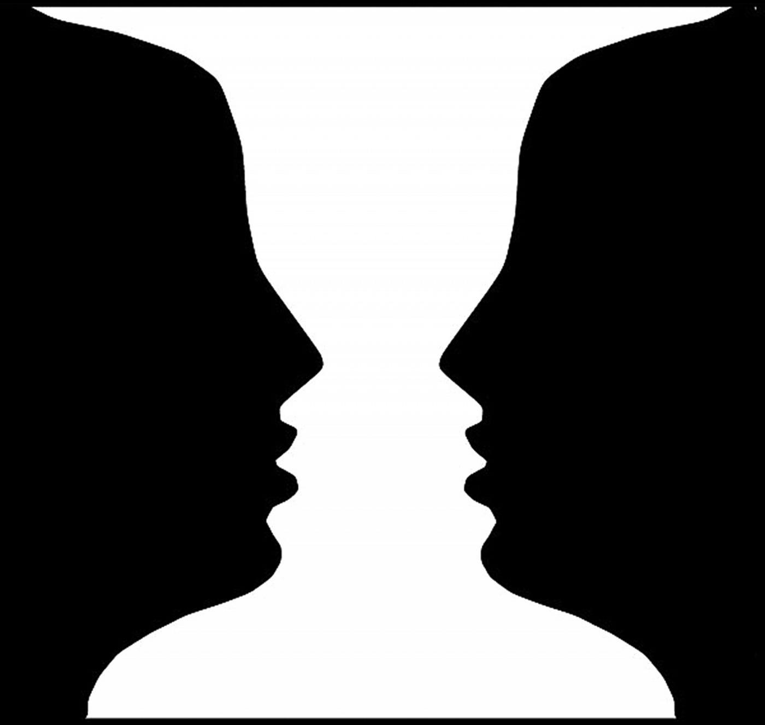

Gestalt Theory is one of the major theories under the Cognitive Perspective. It was developed by German psychologists who believed that people naturally perceive objects and situations as complete wholes rather than separate parts. The word "Gestalt" is a German term that means "whole" or "complete form." The main principle of this theory is "The whole is greater than the sum of its parts."
This means that when people observe something, the brain automatically organizes individual pieces of information into one meaningful whole. Instead of analyzing every detail separately, the mind first recognizes the overall pattern or image.
For example, when you see a bicycle, your brain immediately recognizes it as a bicycle. You do not first identify the wheels, handlebars, pedals, and seat before understanding what it is. Your brain combines all these parts into one complete object.
Gestalt Theory also explains several principles of perception:
Similarity refers to the tendency of the brain to group objects that look alike. Objects with the same color, shape, or size are naturally seen as belonging together.
Proximity explains that objects placed close to one another are perceived as part of the same group.
Closure means that the brain naturally fills in missing parts of an incomplete image. Even if a drawing has gaps, people still recognize the complete object.
Continuity states that the eyes naturally follow smooth and continuous lines instead of broken or disconnected patterns.
These principles help explain how people organize and understand visual information quickly and efficiently.

Field Theory (Kurt Lewin)
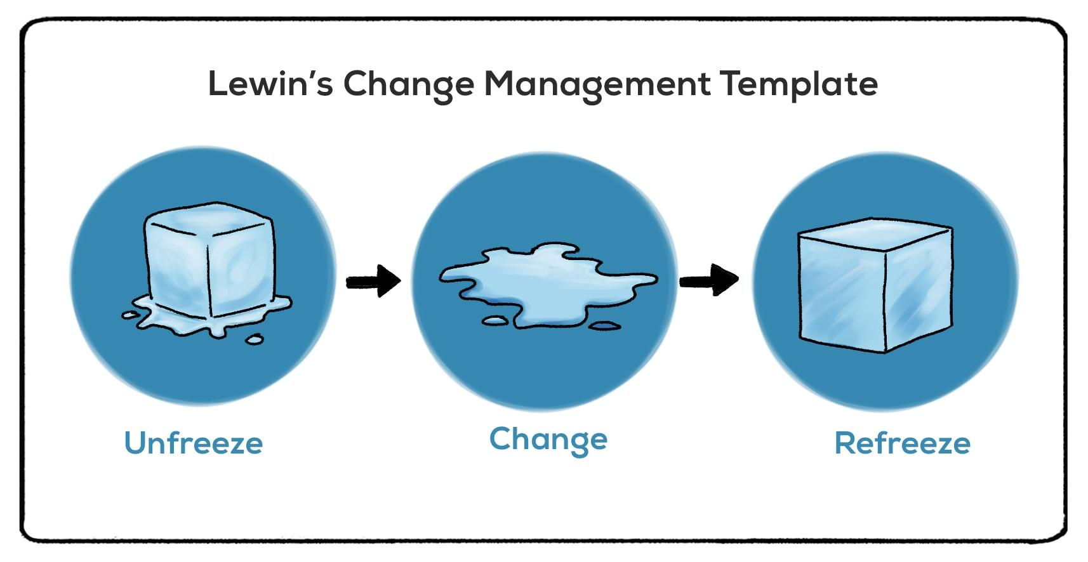
Field Theory was developed by Kurt Lewin. This theory explains that learning and behavior are influenced by both the individual and the environment. Lewin believed that behavior cannot be explained by personal characteristics alone because the environment also plays a significant role.

He summarized this idea using the formula:
Behavior (B) = Person (P) + Environment (E)
This means that a person's actions are affected by who they are and by the surroundings in which they live or learn.
For example, imagine two students preparing for an examination. One studies in a quiet library, while the other studies in a noisy place. Even if both students are equally intelligent, the student in the quiet environment is more likely to concentrate and learn effectively. This example shows that a positive learning environment can improve academic performance.
For teachers, Field Theory emphasizes the importance of creating a classroom that is safe, organized, supportive, and free from unnecessary distractions.

Intelligence Theories
Intelligence refers to the ability to think, reason, solve problems, understand ideas, learn from experience, and adapt to new situations. Different psychologists have proposed different explanations of intelligence. Two of the most influential theories were developed by Alfred Binet and Charles Spearman.

Alfred Binet's Theory of Intelligence
Alfred Binet is widely known as the Father of Intelligence Testing because he developed the first practical intelligence test. His goal was to identify students who needed additional educational support.
Binet believed that intelligence is the ability to reason, understand, solve problems, make good decisions, and adapt to different situations. He also believed that intelligence is not fixed and can improve through proper education, practice, and learning experiences.
For example, if two students are given a difficult mathematical problem, the student who understands how to solve the problem instead of simply memorizing formulas demonstrates intelligence according to Binet's theory.
Binet's theory reminds teachers that every learner has the potential to improve through effective instruction and continuous learning.

Charles Spearman's Theory of Intelligence

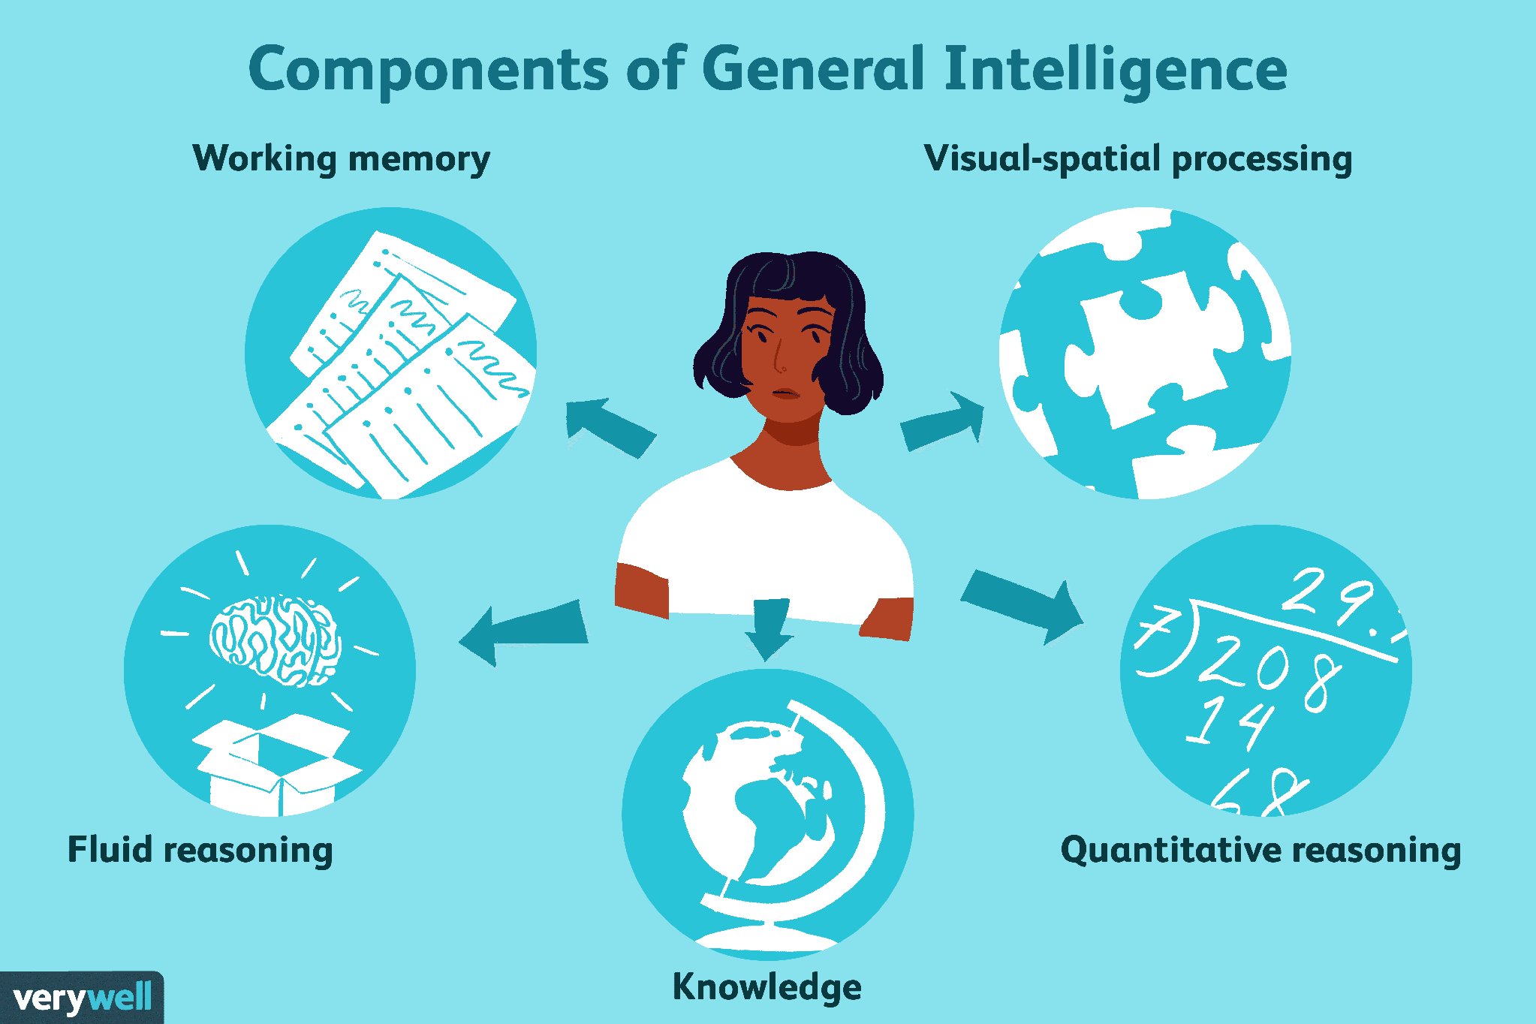
Charles Spearman introduced the Theory of General Intelligence, commonly known as the g-factor Theory. He believed that every person possesses one general mental ability called the g-factor, which influences performance in many different intellectual tasks.
According to Spearman, students with a strong general intelligence often perform well in different academic subjects because the same mental ability supports various kinds of thinking.
He also proposed the s-factor, which refers to specific abilities or talents unique to certain tasks. While a person may have strong general intelligence, they may also possess special talents in areas such as music, art, sports, or language.
For example, a student who consistently performs well in mathematics, science, and logical reasoning may have a strong g-factor. Another student may be exceptionally talented in music or painting because of strong specific abilities.
Spearman's theory explains why people may share overall intellectual ability while still having different strengths and talents.

Comparison of Binet and Spearman
Although both psychologists studied intelligence, they explained it differently. Alfred Binet believed that intelligence is mainly the ability to reason, solve problems, and adapt to situations. He also believed that intelligence can improve through education and experience.
Charles Spearman, on the other hand, believed that intelligence consists of one general mental ability called the g-factor that affects performance across many different tasks. He also recognized specific abilities, known as the s-factor, which explain why individuals have unique talents.

Importance of Cognitive Perspectives and Intelligence Theories in Education
Understanding Cognitive Perspectives and Intelligence Theories helps teachers become more effective educators. These theories remind teachers that learning is an active mental process and that students learn differently depending on how they think, understand, and interact with their environment. They also emphasize that intelligence is not simply about memorizing facts but involves reasoning, understanding, and solving problems.
As future teachers, it is important to recognize that every learner has different abilities, strengths, and learning needs. By understanding these theories, educators can create lessons that encourage critical thinking, meaningful learning, and equal opportunities for every student to succeed.

